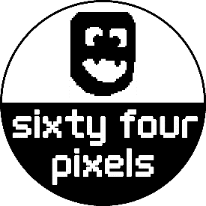

## LE STRUM &

LE GRAND STRUM

## User Guide Firmware V5

## Welcome!

Le Strum and Le Grand Strum are MIDI controllers that let you play musical chords with a strumming action. While these two devices have different shapes and sizes, both instruments function in the same way and this manual uses the generic term ‘Le Strum’ to refer to either.

So what exactly does it mean to strum chords over MIDI? Well MIDI stands for **Musical Instrument Digital Interface,** and it is a way for electronic musical devices and instruments to control each other

MIDI can be sent between devices using a several different types of connection. The ‘traditional’ type of connection is a circular connector with 5 pins (‘5 pin DIN connector’) as shown in the photo below

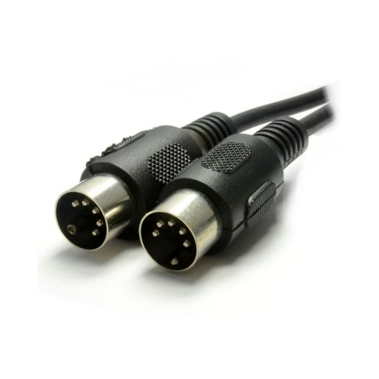

You can also find 3.5mm mini-jacks, USB, and even Bluetooth or Wi-Fi as ways for MIDI information to be sent between devices. Le Strum uses a 5-pin DIN connection for MIDI.

It is important to realise that Le Strum is a MIDI Controller and does not make any sounds by itself. This means that you need a MIDI-controlled synthesizer to actually make the sounds. This could be a laptop computer running music software (such as Logic, Reason, Ableton etc), a hardware synthesizer or sound module, a digital piano or a cheap music keyboard (provided that it has a MIDI input)

Since Le Strum can play several notes at the same time (chords), it works best with a polyphonic sound source (i.e. where multiple notes can be playing at the same time). Ideally your sound source should have 8 note polyphony or more, but you can still have fun with less notes than this.

If you are using a hardware sound source (like a keyboard synth), you can simply connect a MIDI cable from Le Strum’s MIDI output to the MIDI IN socket of the sound source

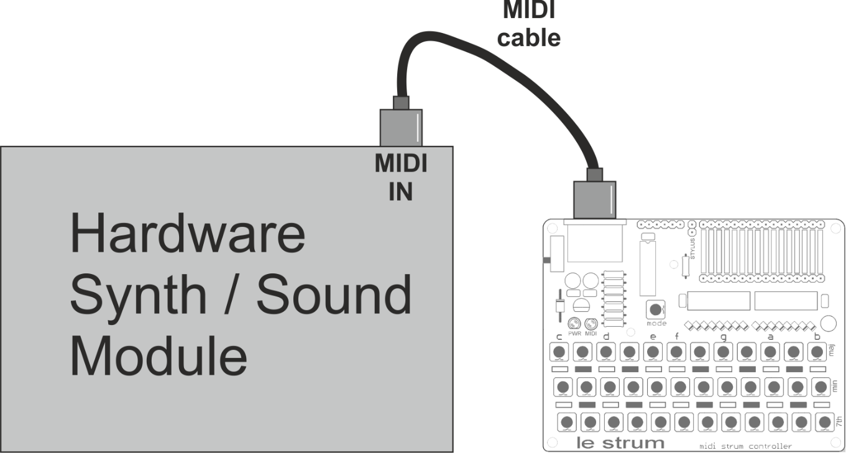

If your hardware synth has a 3.5mm socket for MIDI IN then you will also need a 5-pin MIDI to mini-jack adaptor suitable for your equipment (most equipment uses the “Type A” polarity for mini jack MIDI but check your device – some older devices from Novation, Arturia and some others use the “type B” polarity)

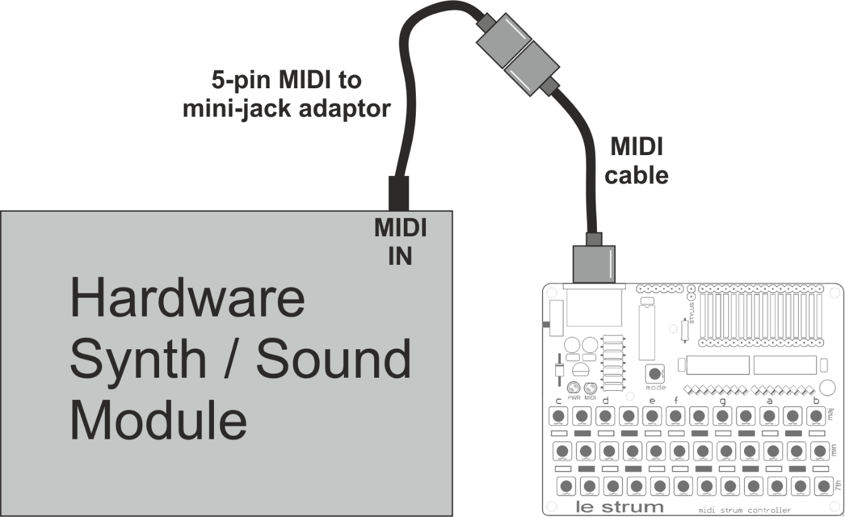

If you are using a computer as a sound source (using a suitable music program) then your computer will need to have a MIDI interface attached to it. If you have a desktop computer with a dedicated soundcard, you may have a MIDI interface built into your sound card. In most cases (and especially with laptop computers) however, you will need an external MIDI interface connected to the computer via USB or similar.

The cheapest and simplest option is usually to purchase a USB to MIDI interface cable. There are many types of these available from multiple sources. A reasonably priced option I have found to work well is the M-Audio USB UNO although there are many others available.

When using a USB to MIDI cable you connect the MIDI IN plug to Le Strum and the USB plug into your computer. The MIDI OUT plug is not used in this case (Note that some cables confusingly label MIDI IN as “To MIDI OUT” so try both plugs if it doesn’t work first time)

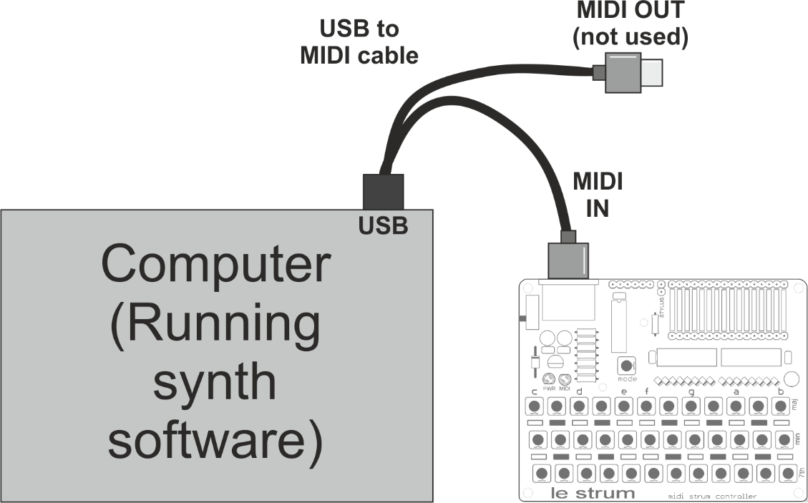

To use Le Strum with a computer as the sound source, you will need to

* be running suitable software on the computer
* configure your software to receive MIDI from Le Strum

Typically, the software will be a Digital Audio Workstation (DAW) program such as REAPER, Reason, Ableton Live, Logic etc. with a suitable synth plug-in.

If you do not already own a DAW program, you could download a demo version; while this might have a limitation such as not being able to save/load projects this won’t matter if you are just using it to play live sounds from MIDI. A great option is to install REAPER (an excellent shareware DAW) and find a suitable VST plug-in to make the sounds.

When configuring your MIDI input, you need to be aware that Le Strum will not show up by name in your list of MIDI devices. Instead, you will see the name of your MIDI interface (for example “USB MIDI”) to which Le Strum is attached. This is the device you should select as your MIDI input.

By default Le Strum sends out MIDI note information on MIDI Channel 1. In some operating modes, additional notes are be sent out on MIDI Channel 2

|  |
| --- |
| NO MIDI OUTPUT?  Please note that in most operating modes, **Le Strum only sends MIDI notes while a chord button is held while you are strumming**. You can change this behaviour as described later. |

## Know your Le Strum

The main parts of Le Strum are labelled on the diagram below:

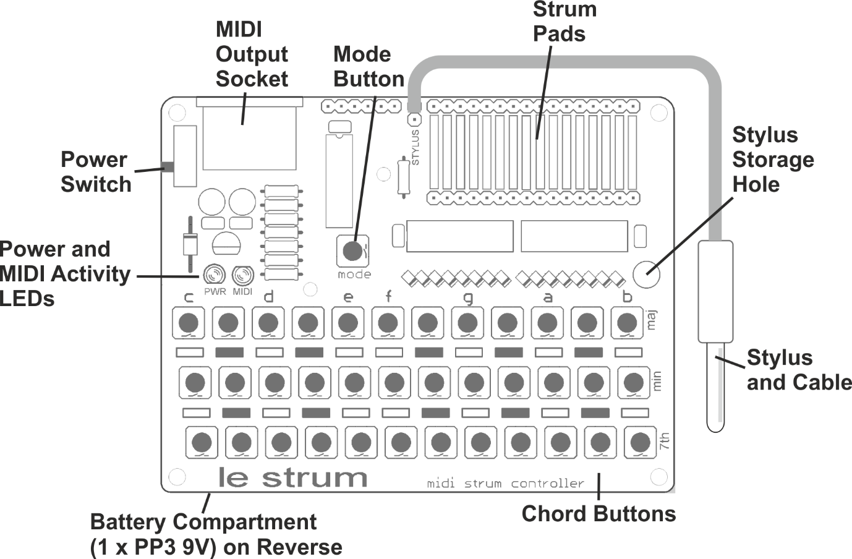

* Le Strum usually runs from a **9V battery (PP3)** inserted into the battery box on the reverse of the unit. The battery should be removed if the unit is not to be used for a long period of time.
* Power is applied by switching on the **power switch**. When power is available, the red **PWR LED** should be lit. Switch the power off when not using the unit to maximise battery life.
* Le Strum is a MIDI controller and does not make any sound by itself. In order to play notes with Le Strum you need to connect a synthesizer, sound module or computer to the **MIDI output socket.**
* There are 36 **chord buttons** arranged in a 12 x 3 grid (12 notes of the octave with a major, minor and seven chord type buttons per note). The function of these buttons will be explained later in this manual.
* A separate **MODE button** allows special functions of the Le Strum to be activated when it is used in combination with the chord buttons. This will be explained later in the manual.
* Attached to the unit is a **stylus** on the end of a short cable. The stylus is used to pick notes out of a chord that has been previously selected via the chord buttons. The notes are played by touching the stylus to one or more of the strum pads, or touching several in sequence with a “strum” action.
* When the unit is not in use, we recommend the stylus is pushed through the **stylus storage hole** on the right side of the unit, this helps prevent the cable being accidentally pulled and broken.
* The blue **MIDI Activity LED** blinks when MIDI information (note on and/or note off messages) is being sent out by Le Strum. You should see this blink when strumming – you might also see it blink when pressing or releasing the chord buttons (depending on mode). Le Strum usually only sends MIDI notes when the stylus is strummed across the pads **when a chord button is held down at the same time.**

## Know your Grand Strum

The main parts of Le Grand Strum are labelled on the diagram below:

* Le Grand Strum runs from a **9V battery (PP3)** inserted into the battery box. The battery should be removed if the unit is not to be used for a long period of time.
* Power is applied by sliding the **power switch** to the right. When power is available, the red **PWR LED** should be lit. Switch the power off when not using the unit to maximise battery life.
* Connect your synthesizer, sound module or computer to the **MIDI output** socket using a suitable MIDI interface or cable.
* There are 36 **chord buttons** arranged in a 12 x 3 grid (12 notes of the octave with a major, minor and seven chord type buttons per note). The function of these buttons will be explained later in this manual.
* A separate **MODE button** allows special functions of the Le Grand Strum to be activated when it is used in combination with the chord buttons. This will be explained later in the manual.
* Attached to the unit is a **stylus** on the end of a short cable. The stylus is used to pick notes out of a chord that has been previously selected via the chord buttons. The notes are played by touching the stylus to the pads on one of the three **strum plates**.
* The main strum plate has 16 pads and is tapered, so that you can play fast strums close to the top of the plate and pick out individual notes close to the bottom of the plate where the pads are furthest apart.
* There are two circular arpeggio plates, which can be used as an alternative to the main strum plate and operate in the same way. The circular plates make it easy to play in patterns that would be more difficult on the main plate: The left plate allow easy playing of specific notes of a chord over multiple octaves and the right plate allows repeating cycles of notes to be played smoothly by moving the stylus in a circular motion

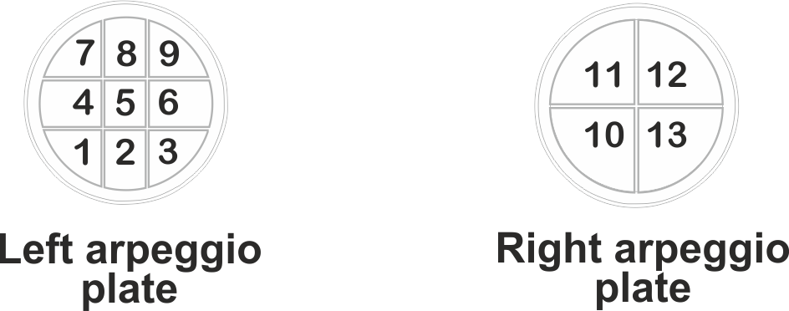

The above pictures show how pads on the two circular strum plates map to the first 13 pads of the main strum pad (counting from the left). Note that the placement of notes on the circular pads will depends on whether a basic 3 note triad is being played (major, minor) or a 4-note chord. In guitar voicing mode not all the of the pads will sound.

* When the unit is not in use, we recommend the stylus is pushed through the leather **stylus holder** tabon the rear of the unit, this helps prevent the cable being accidentally pulled and broken.
* The blue **MIDI Activity LED** blinks when MIDI information (note on and/or note off messages) is being sent. You should see this blink when strumming – you might also see it blink when pressing or releasing the chord buttons (depending on mode). Le Grand Strum usually only sends MIDI notes when the stylus is strummed across the pads **when a chord button is held down at the same time.**

## Basic Strumming

Let’s start with a basic chord strum! Turn the unit off and back on, to make sure it’s in the default mode, then press and hold the top left chord button and strum the stylus from left to right across all sixteen strum pads.

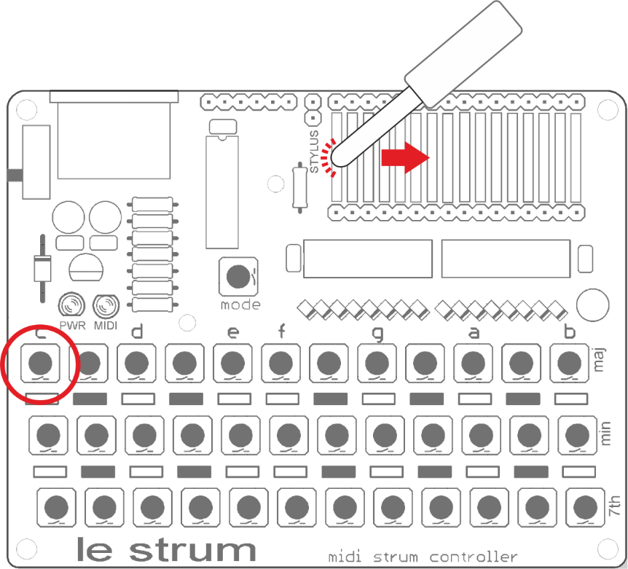

You should get a nice C major strum across several octaves! Try moving the stylus left and right a few pads at a time to vary the strum.

Now let’s try a chord progression… press and hold each of the buttons in turn as indicated and give each chord a strum. Get creative with the strumming patterns!

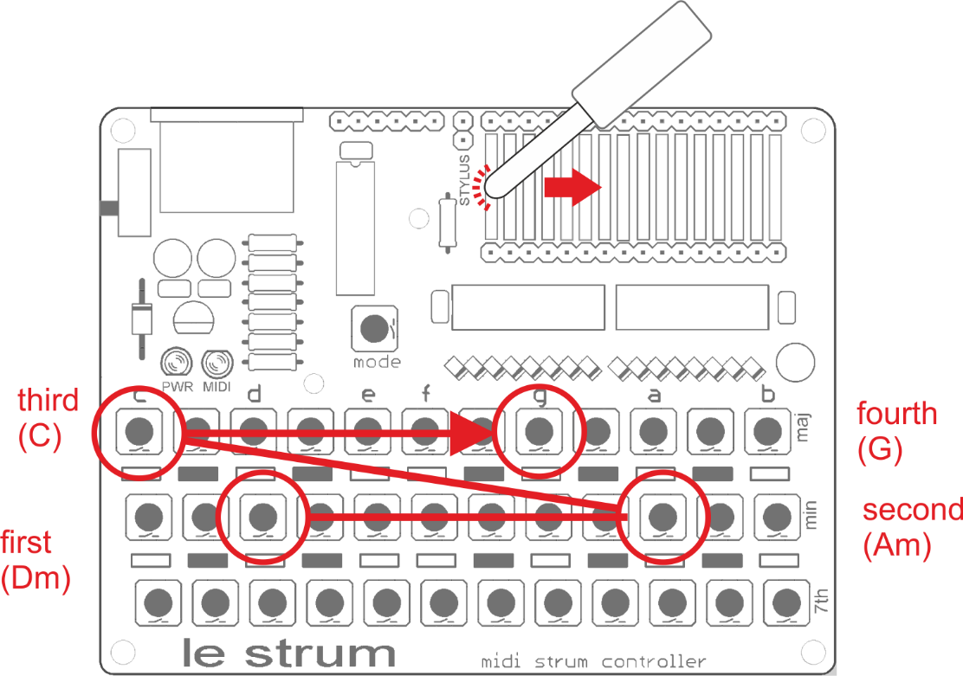

This progression shows how the major and minor chords are arranged along the top two rows of the chord buttons. The letters printed above the top row show the chord root notes, C through B with unlabelled buttons to the right of C, D, F, G, A being the sharp (black note) for the labelled note to their right. In this way the buttons are like a single octave of a piano keyboard:

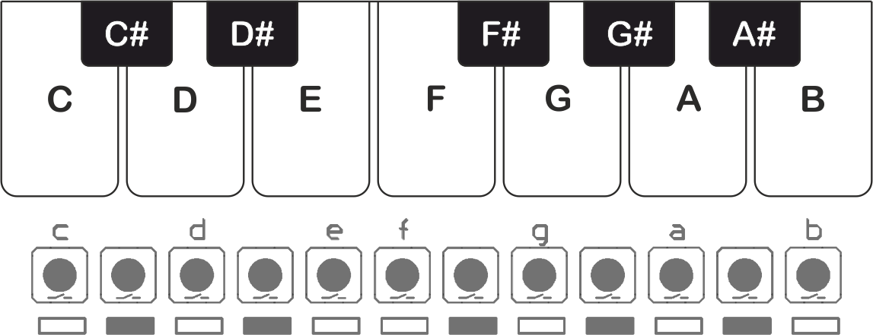

* The first row of chord buttons selects **major** chords (often just written as a root note, e.g. “A”)
* The second row of chord buttons select **minor** chords (often written with a small “m”, e.g. “Am”)
* The first row of chord buttons selects **seventh** (dominant seventh) chords (often written with a digit 7, like “A7”)

Combinations of chord buttons in the same column (same root note) select the following extended chords:

* Pressing the top and bottom rows (major and seventh) selects the **major seventh** chord.
* Pressing the middle and bottom rows (minor and seventh) selects the **minor seventh** chord.
* Pressing the top and middle rows (major and minor) selects the **diminished** chord (often written with a ⭘ symbol like “A⭘”).
* Pressing all three rows (major, minor and seventh) selects the **augmented** chord (often written with a + symbol like “A+”).

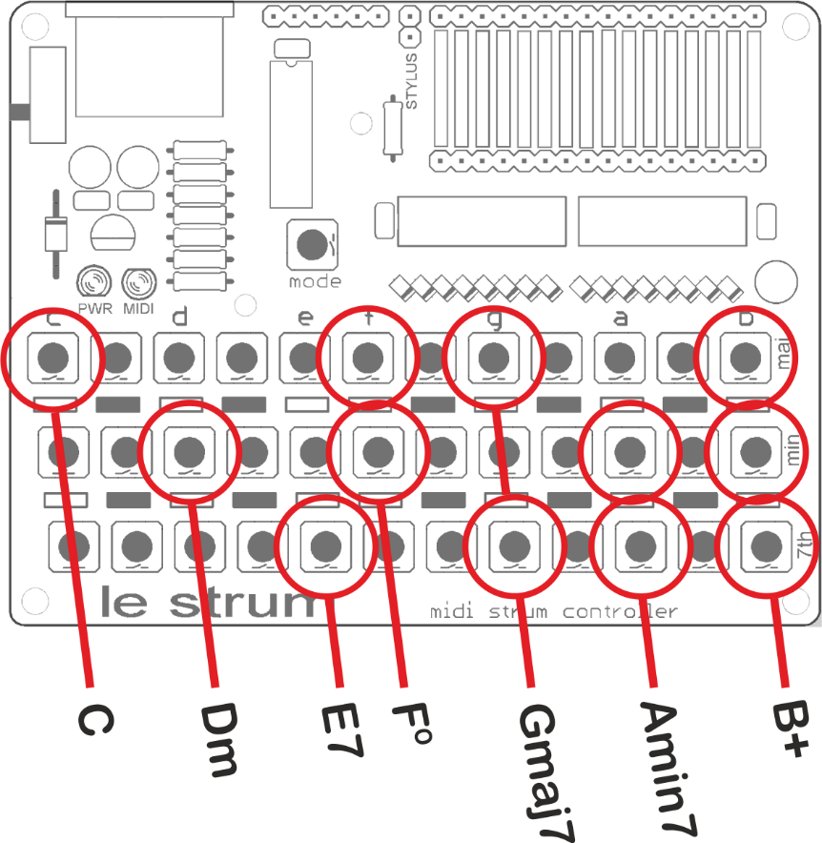

Don’t worry if you don’t know what all these chords are or how to use them, but perhaps try them out to get used to their sounds!

In certain play modes (described later), you can add notes to a basic chord which you are already holding, to create an extended chord. If you press a button in the column to the right of the chord, you can select one of the following added notes:

* Pressing a chord button on the top row adds the **fourth** note of the scale, allowing the suspended fourth (sus4) variation of a chord to be played.
* Pressing a chord button on the middle row adds the **sixth** variation of the scale to a chord.
* Pressing a chord button on the bottom row adds the **ninth** (second note of scale raised by an octave) to a chord.

While continuing to hold the chord buttons in the root note column you can release the added note button to return to the original chord, and you can press it again to go back to the added note. Only one of these notes can be added to the chord at a given time.

For example, here is how the fourth note of the scale could be added to D minor to give a Dmsus4 chord. Note that the Dm chord (D root, middle row) must be selected and held first, the button for the added note (top row of column to right of root note) can then be pressed

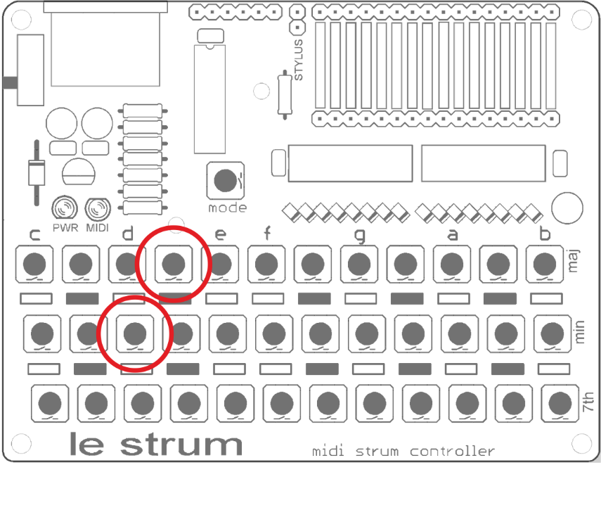

Note that these extra notes cannot be added to B chords (since B is the rightmost root note column!)

## Pre-Defined Play Modes

Le Strum has six pre-defined play modes that are accessed by holding the MODE button and clicking on one of the chord buttons from the top row.

Each play mode defines a combination of options for:

* **Voicing** (meaning how the notes on the touch pads are selected from the notes of the chord or scale)
* **Articulation** (whether the note plays or stops when you touch a pad, and what effect releasing a chord button has on the notes that are playing)
* **Other options**, such as whether notes can be added to created extended chords and if the chord triad plays on a second MIDI channel while the chord button is held (‘organ buttons’ mode)

|  |  |
| --- | --- |
| Combination |  |
| MODE + C | **Basic Strum Mode**   * Normal voicing * Note plays at contact break * Notes are damped when no chord button is pressed * Common notes are sustained when changing chords |
| MODE + D | **Guitar Voicing Mode**   * Guitar chord voicing * Can add notes to chord * Note plays at contact break * Notes are damped when no chord button is pressed * Common notes are sustained when changing chords |
| MODE + E | **Guitar Voicing with Sustain**   * Guitar chord voicing * Can add notes to chord * Note plays at contact break * Notes continue to play no chord button is pressed * Common notes are sustained when changing chords |
| MODE + F | **Basic Strum + Organ Buttons**   * Normal voicing * Note plays at contact break * Notes continue to play no chord button is pressed * Common notes are sustained when changing chords * Chord triad plays on second MIDI channel |
| MODE + G | **Basic Strum + Organ Buttons + Added Notes**   * Normal voicing * Can add notes to chord * Note plays at contact break * Notes continue to play no chord button is pressed * Common notes are sustained when changing chords * Chord triad plays on second MIDI channel |
| MODE + A | **Basic Strum + Organ Buttons + Added Notes + Retrigs**   * Normal voicing * Can add notes to chord * Note plays at contact break * Notes continue to play no chord button is pressed * Common notes are sustained when changing chords * Chord triad plays on second MIDI channel * Chord triad is retriggered when button is pressed again |
| MODE + B | **User Custom Mode**   * Combination of options set by user |

## Normal Chord Voicing

Le Strum spreads the notes of a simple 3-note chord across the strum pads by “stacking” the chord triad, adding sequential notes of the chord in ascending octaves to assign notes to all sixteen strum pads.

For example, here is how the three-note D Minor triad (consisting of the notes D, F#, A) gets mapped to strum pads of both Le Strum and Le Grand Strum

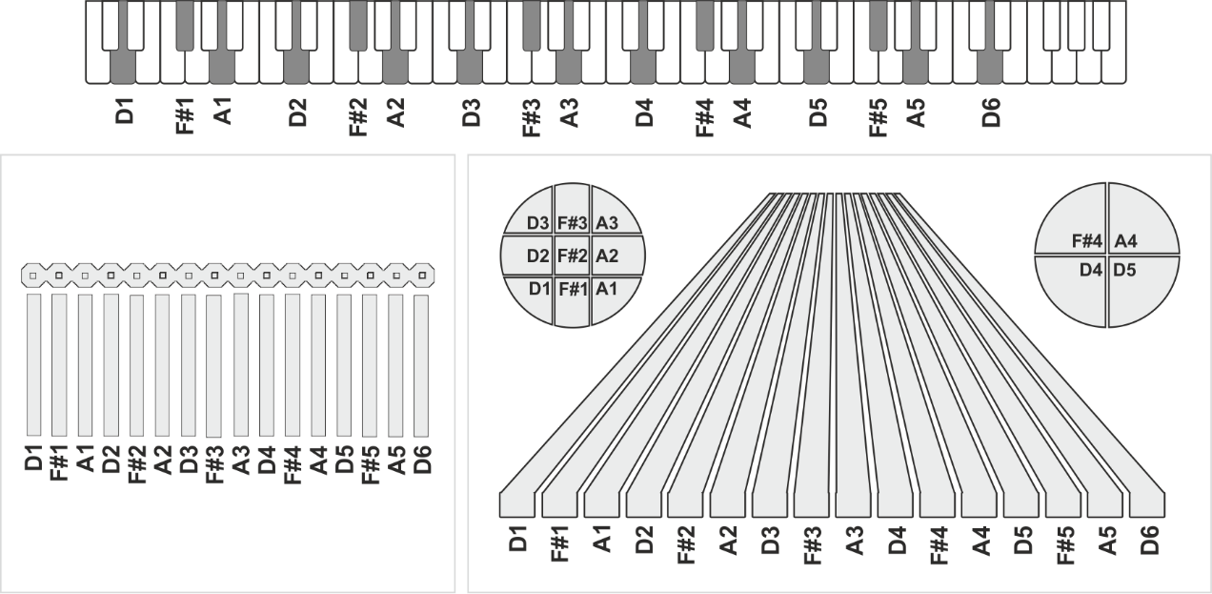

Many chords that can be selected from the keyboard consist of four or more notes. They are mapped in a similar way, although the 16 strum pads will span fewer octaves (since more notes are mapped from each octave). For example, an A Maj7 chord consists of the four notes A, C#, E#, G#. This chord gets mapped as follows:

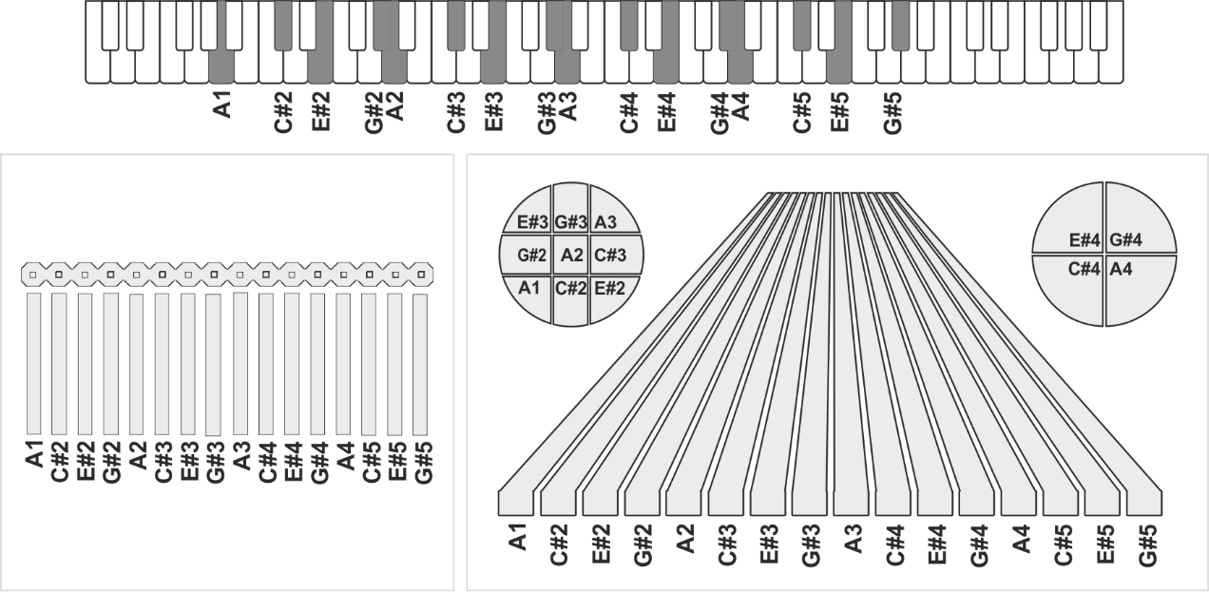

Note how, on the Le Grand Strum, the pads of the left arpeggio plate are mapped to the notes from the first nine strum pads on the main plate, and the right arpeggio plate picks up the next four notes.

## Guitar Chord Voicing

In the “Guitar Voicing” modes, Le Strum maps the notes of the most common chords to the strum plate pads, based on the way those chords would be played on a guitar. This helps to achieve a more convincing impression of guitar strumming (when used with a suitable guitar sound!) than is possible in the normal stacked triad chord mapping modes.

Here is an example showing how a G Major chord is mapped in Guitar voicing mode.

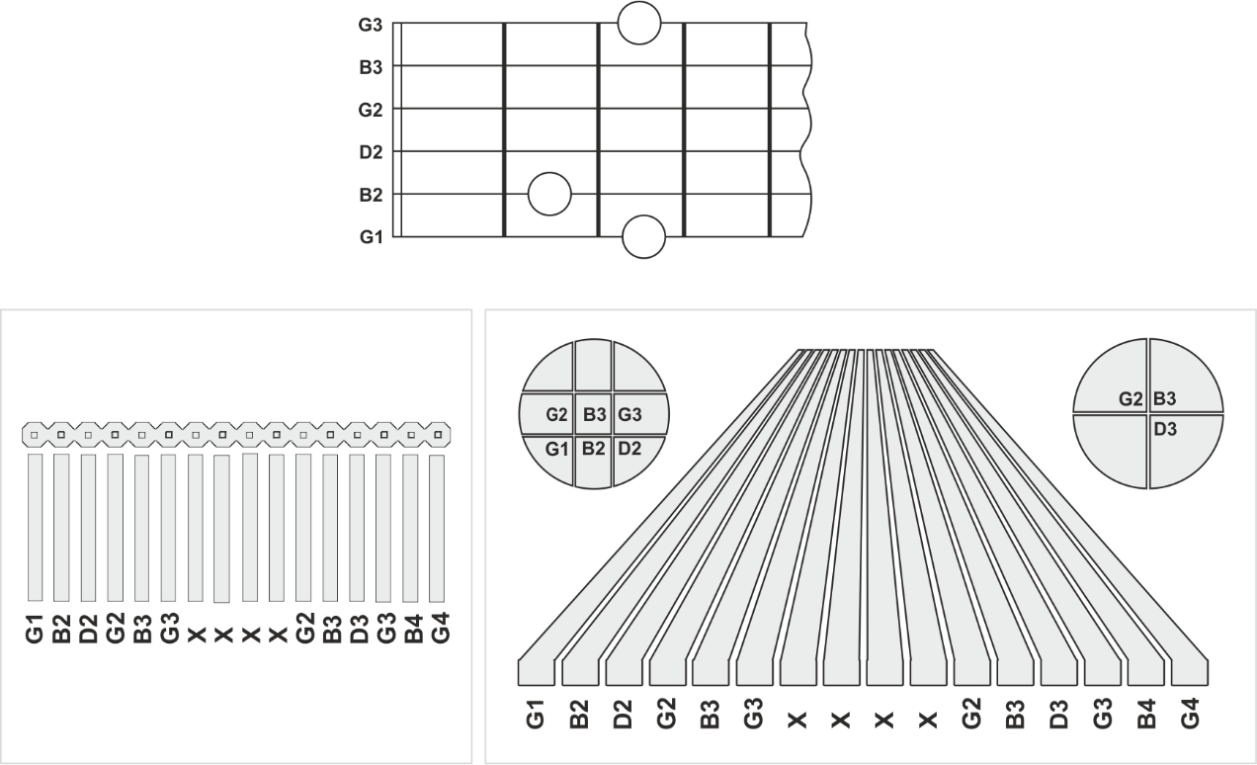

Note that the guitar-voiced chord has a maximum of 6 notes (the number of strings on a guitar) so only the right-most 6 pads are active. The chord is also transposed up one octave and mapped to the left-most six pads. The four pads in the middle are not used.

Note that many guitar chords do not include all six strings. Unused strings are “muted” (nothing is played when they are strummed with the stylus).

The following table shows how Major, Minor and 7 chords are voiced in guitar mode. Other chords (e.g. major 7) are built using stacked triads.

|  |  |  |  |
| --- | --- | --- | --- |
|  | Maj | Min | 7 |
| C | C shape open | Am shape 3rd fret* | C7 shape open* |
| C# | A shape 4th fret* | Am shape 4th fret* | A7 shape 4th fret* |
| D | D shape open** | Dm shape open** | D7 shape open** |
| D# | A shape 6th fret* | Am shape 6th fret* | A7 shape 6th fret* |
| E | E shape open | Em shape open | E7 shape open |
| F | E shape 1st fret | Em shape 1st fret | E7 shape 1st fret |
| F# | E shape 2nd fret | Em shape 2nd fret | E7 shape 2nd fret |
| G | G shape open | Em shape 3rd fret | E7 shape 3rd fret |
| G# | E shape 4th fret | Em shape 4th fret | E7 shape 4th fret |
| A | A shape open* | Am shape open* | A7 shape open* |
| A# | A shape 1st fret* | Am shape 1st fret* | A7 shape 1st fret* |
| B | A shape 2nd fret* | Am shape 2nd fret* | A7 shape 2nd fret* |

* Since the lowest string (E) on a guitar is not played for this chord, the first strum pad does not have a note mapped to it

** Since the lowest two strings (E, A) on a guitar are not played for this chord, the first two strum pads do not have notes mapped to them

## Play Options

Once you have selected a predefined play mode, you can customise it by selecting different play options. Any changes you make last until you select a new play mode (although you can save a “user patch” as described later)

Play options can be selected (turned on/off or select between two or more values) by holding the MODE button and pressing one of the chord buttons from the second or third row.

|  |  |
| --- | --- |
| Combinations |  |
| **Articulation Options**  Usually the note starts playing when the stylus breaks contact with the strum pad and stops when the pad is touched. This is supposed to replicate the feel of picking a string. However you can customise this behaviour, so the note starts playing when the pad is touched and stops when released, or even to play when touched and released. | |
| MODE+Cm | The note **starts** playing when **contact is made** with the pad |
| MODE+C7 | The note **stops** playing when **contact is made** with the pad |
| MODE+C#m | The note **starts** playing when **contact is** **broken** with the pad |
| MODE+C#7 | The note **stops** playing when **contact is** **broken** with the pad |
| **Chord Voicing Options**  These options | |
| MODE+Dm | **Use Guitar Chord Voicing**  If the option is ON, Guitar Chord Voicing is active on the leftmost six pads of the strum plate and the remaining pads are inactive (see below). Otherwise normal (stacked triads) voicing is active on all the 16 pads. |
| MODE+D7 | **Guitar Chord Voicing on Upper Octave**  When guitar chord voicing is active, if this option is ON, the rightmost six pads of the strum pad duplicate the chord notes transposed up one octave. If OFF, only the leftmost six pads are active |
| MODE+D#m | **Enable Added Notes**  When this option is ON it is possible to make extended chords (sus4, add6, add9) by pressing chord buttons to the right of the chord selection button (described earlier in the manual) |
| MODE+D#7 | **Include Bass Notes in Guitar Voicing**  Some guitar voiced chords mute the lower one or two strings, so the corresponding strum pads are muted. When this option is ON these low strings are active and can be picked a bass notes to the chord |
| MODE+Em  MODE+E7 | **Note Sustain Options**  Usually all notes of a chord are stopped when the chord button is released, however there are two options that can let notes of a chord “ring on”  MODE+Em selects “Sustain until change of chord” which means that the chord notes are not stopped when the chord button is released but are not stopped until the next chord is selected.  MODE+E7 selects “Sustain common notes” which means that when a new chord is selected, only notes which not part of the new chord are stopped  These two modes are mutually exclusive |
| MODE+Fm  MODE+F7  MODE+F#7 | **Lead Scale Options**  These options map the strum pads to a fixed scale, rather than to the selected chord. This allows lead melodies to be played and works best when used in conjunction with “organ buttons” modes (so that the chord buttons can be used to select a backing chord for a melody)  MODE+Fm selects a chromatic scale from C  MODE+F7 selects a major scale from C  MODE+F#7 selects a pentatonic scale from C  These three modes are mutually exclusive |
| MODE+Gm | Backing Chord on MIDI Channel 2 (‘Organ Buttons’)  When this option is ON, pressing a chord button immediately plays the 3 or 4 notes of the basic chord (usually in a low octave) on MIDI Channel 2. This can be mapped to a different sound to the main strum voice on Channel 1 to back up the strumming, rather like the backing chord buttons on some old organs (hence “organ buttons”!) |
| MODE+G#m  MODE+G#7 | **Backing Chord Sustain Options**  Usually all notes of the backing chord are stopped when the chord button is released, however there are two options that can let notes of a chord “ring on”  MODE+G#m selects “Sustain until change of chord” which means that the chord notes are not stopped when the chord button is released but are not stopped until the next chord is selected.  MODE+G#7 selects “Sustain common notes” which means that when a new chord is selected, only notes which not part of the new chord are stopped  These two modes are mutually exclusive and only apply when the backing chord mode is enabled |
| MODE+Am | **Select MIDI Channel for Strum**  While this combination of buttons is held, press the stylus to one of the 16 strum pads to select MIDI channel 1-16 for output of the main chords strums (default channel: 1). There is a short delay while the information is saved. The channel is saved during power off. |
| MODE+A7 | **Select MIDI Channel for Backing Chords**  While this combination of buttons is held, press the stylus to one of the 16 strum pads to select MIDI channel 1-16 for output of the backing chords (default channel: 2). There is a short delay while the information is saved. The channel is saved during power off. |
| MODE+A# | **Select MIDI Velocity for Strum**  While this combination of buttons is held, press the stylus to one of the 16 strum pads to select one of 16 MIDI note velocities for the main chord strum (default velocity: 127/Full) |
| MODE+A#m | **Reverse Pad Layout**  This option reverses the mapping of notes to the main strum pads and is intended for use in customised hardware where the strum direction is from right to left. This setting is saved during power off. |
| MODE+A#7 | **Circle Of Fifths Layout**  This option changes the mapping of chord root notes in the keypad columns so that, rather than them being arranged in a chromatic scale, the root notes are arranged in a “circle of fifths” rather like on an accordion.   |  |  |  |  |  |  |  |  |  |  |  |  |  | | --- | --- | --- | --- | --- | --- | --- | --- | --- | --- | --- | --- | --- | | Label | C | C# | D | D# | E | F | F# | G | G# | A | A# | B | | Root Note | **C#** | **G#** | **D#** | **A#** | **F** | **C** | **G** | **D** | **A** | **E** | **B** | **F#** | |
| MODE+B7 | **MIDI Panic**  This is a “command” rather than an option, and it stops all notes playing on the main play channel and (if organ buttons mode is selected) on the organ buttons channel. The command sends MIDI “note off” messages for all notes 0-127 on the channel. |

## User Patch

Each of the predefined play modes for Le Strum is a pre-defined combination of the play options. Once you have selected a predefined play mode, you can customise it by selecting different play options.

You can also save a customised play mode as the “user patch” to be used as the default patch on startup or to be recalled later with a button press. Le Strum supports a single user patch, which you can save to using the MODE+Bm combination. You can recall this patch later using the MODE+B combination.

Hacks and Mods

The Le Strum hardware is designed to be easy to incorporate into your own instrument design. For info and ideas check out **six4pix.com/lestrum**